ELEC-5220

Info. Networks

FROM: Jacob Howard

TO: Dr. Yihan Li & Chao Yang,

DUE DATE: 11/29/21

Lab 8

**Ex1**

*Host 1: arp -a After Ping*

*Host 2: arp -a before and after ping*

*Host 2 Wireshark Ping*

**Q1: Is there any new entries in the ARP tables from after Ping process? If yes, which network interfaces are they for?**

Yes, from the host we pings as shown below in the screenshot.

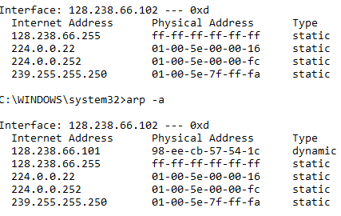

**Q2: Is ARP request sent before or after the Ping request? Who sends the ARP request and whose MAC address is queried? Who is supposed to receive the ARP request?**

Before. Host2 sends request and Host1’s MAC address is queried as shown in the wireshark screenshot below. The wourter is supposed to receive the ARP request.



**Q3: Who sends the ARP reply as a respond to the ARP request in Q2? Who is supposed to receive the ARP reply?**

The router sends replay and Host2 recievess it.



**Q4: List the source IP address, destination IP address, source MAC address, and destination MAC address of the ping request packet.**

Source address: 128.238.66.102**,** Destination address: 128.238.66.101**,** Source MAC address: 98:ee:cb:57:51:09**,** Destination MAC address: 2c:5a:0f:f6:a7:ba

**Q5: List the source IP address, destination IP address, source MAC address, and destination MAC address of the ping reply packet.**

Source address: 128.238.66.101**,** Destination address: 128.238.66.102**,** Source MAC address: 2c:5a:0f:f6:a7:ba**,** Destination MAC address: 98:ee:cb:57:51:09

**Ex2**

**Q6: When host 1 pings host 2, is the Ping process successful? Do you observe any ARP packets and what is the purpose of them? Explain what has happened.**

The ping is unsuccessful because they’re on different subnets. There are some ARP packets, which serve to find the route to the desired IP address but it can’t find it since they’re on different subnets.

*Host 2: arp -a Before and After Ping*

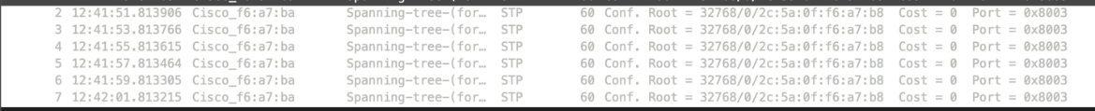

*Host 1 Wireshark Ping*

**Q7: When host 2 pings host 1, is the Ping process successful? Do you observe any ARP packets and what is the purpose of them? Explain what has happened.**

No, unsuccessful. There are 2 ARP packets which help Host2 identify the location of Host1.

**Ex3**

*Host 1: arp -a After Ping*

*Host 2: arp -a Before and After Ping*

*Host 1 Ping Wireshark*

*Host 2 Ping Wireshark*

**Q8: A new entry appeared in host 1’s ARP table after the ping process. Which network interface is it for?**

192.168.10.1 is the new entry

**Q9: A new entry appeared in host 2’s ARP table after the ping process. Which network interface is it for?**

128.238.66.1

**Q10: Whose MAC address is queried in the ARP Request from host 1? Which network interface sends the ARP Reply to host 1?**

The MAC address is ff:ff:ff:ff:ff:ff from Host1. The network interface that responds is 2c:5a:0f:f6:a7:bc.

**Q11: List the source IP address, destination IP address, source MAC address, and destination MAC address of(1) the Ping Request packet captured on host 1 (2) the Ping Reply packet captured on host 1**

**1.**

Source IP: 192.168.10.20

Destination IP: 128.238.66.102

Source MAC: 98:ee:cb:57:54:1c

Destination MAC: 2c:5a:0f:f6:a7:bc

**2.**

Source IP: 128.238.66.102

Destination IP: 192.168.10.20

Source MAC: 2c:5a:0f:f6:a7:bc

Destination MAC: 98:ee:cb:57:54:1c

**Q12: List the source IP address, destination IP address, source MAC address, and destination MAC address of (1) the Ping Request packet captured on host 2 (2) the Ping Reply packet captured on host 2**

**1.**

Source IP: 192.168.10.20

Destination IP: 128.238.66.102

Source MAC: 2c:5a:0f:f6:a7:bc

Destination MAC: 98:ee:cb:57:54:1c

**2.**

Source IP: 128.238.66.102

Destination IP: 192.168.10.20

Source MAC: 98:ee:cb:57:54:1c

Destination MAC: 2c:5a:0f:f6:a7:bc

**Q13: Do you get the same MAC address results for Q11 and Q12? Explain why it happens.**

**The MAC addresses are the same because the network is on the same subnet.**